SIGNALS AND SYSTEMS (IT204)

ASSIGNMENT 7

Name: Sachin Prasanna

Roll no : 211IT058

1) Write a MATLAB/ Python program to find one sided z-transform of the following standard causal signals.

a) n b) an c) nan d) e-anT

**ANSWERS**

**CODE**

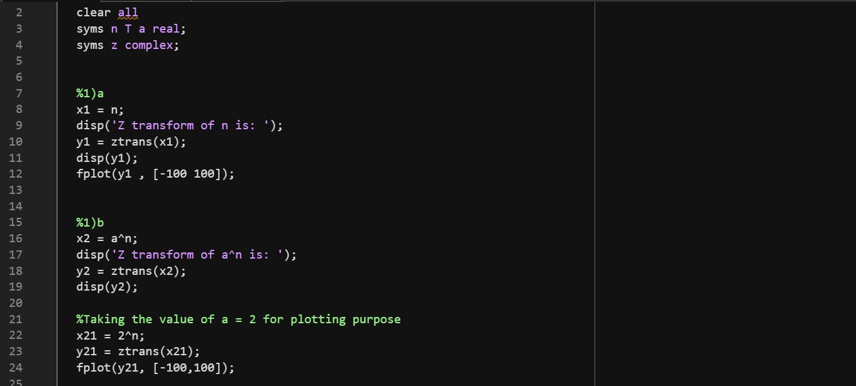

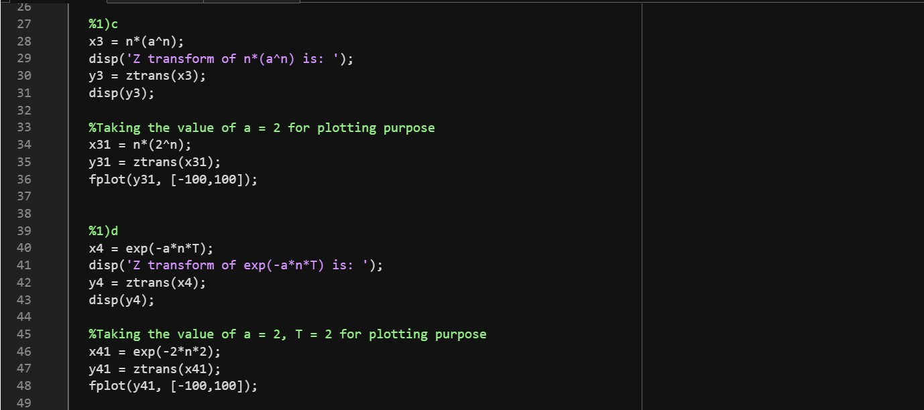

**OUTPUT**

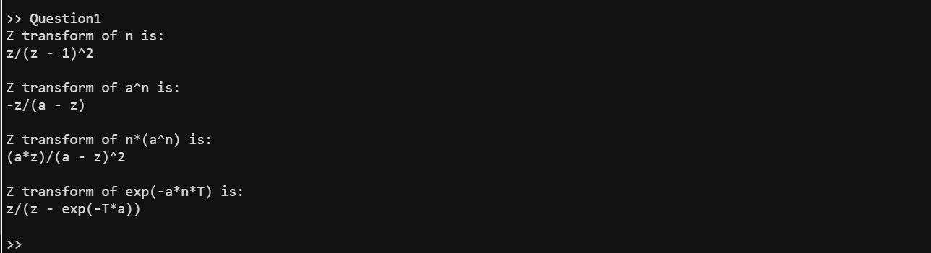

**GRAPHS (one for each subpart, in order)**

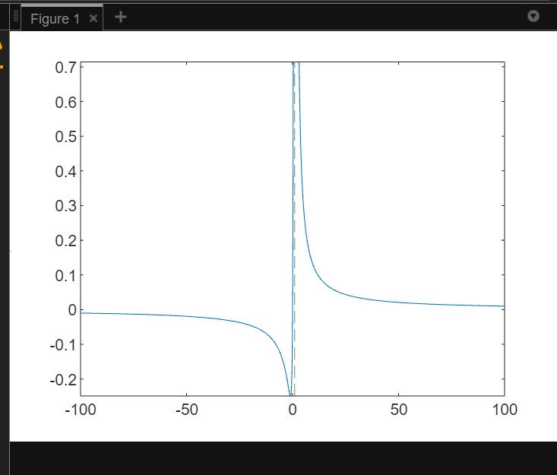

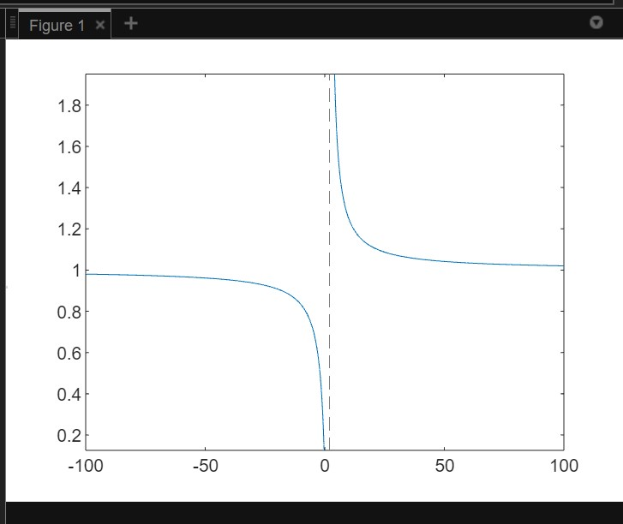

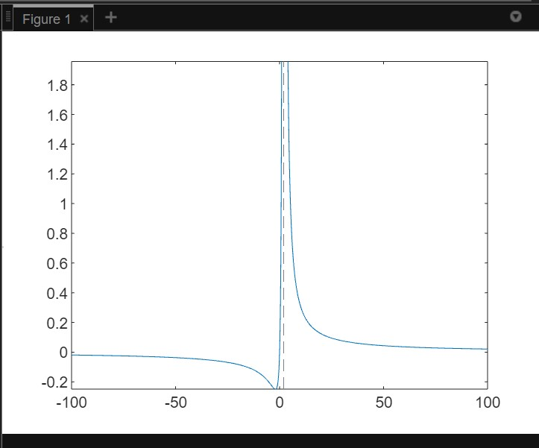

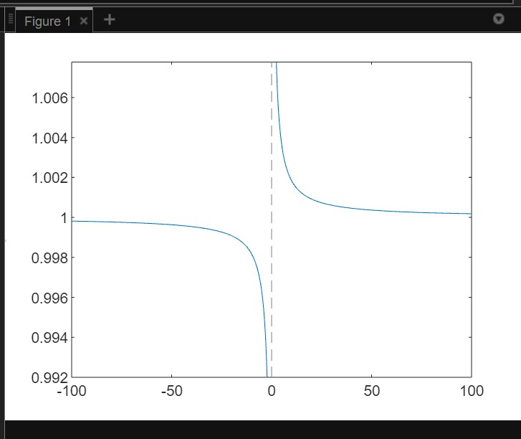

2) Write a MATLAB/ Python program to find z-transform of the following standard causal signals.

a) 0.5n b) 1+n(0.4)(n-1)

**ANSWERS**

**CODE**

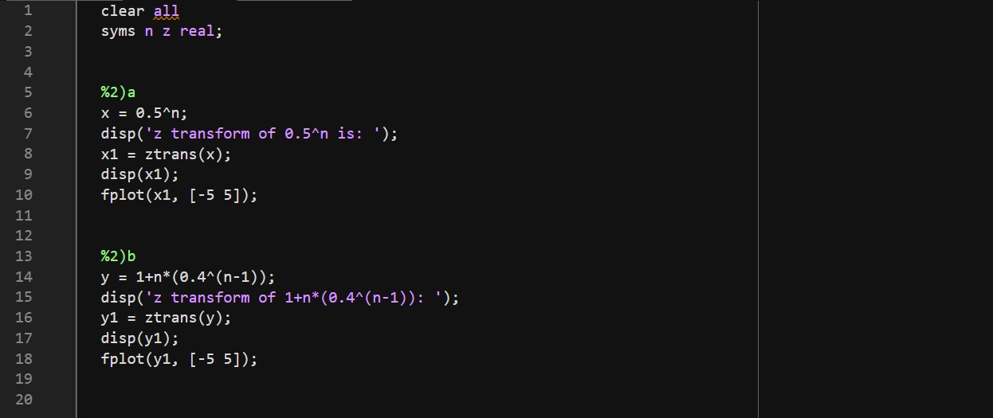

**OUTPUT**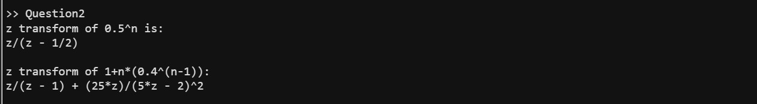

**GRAPHS (one for each subpart, in order)**

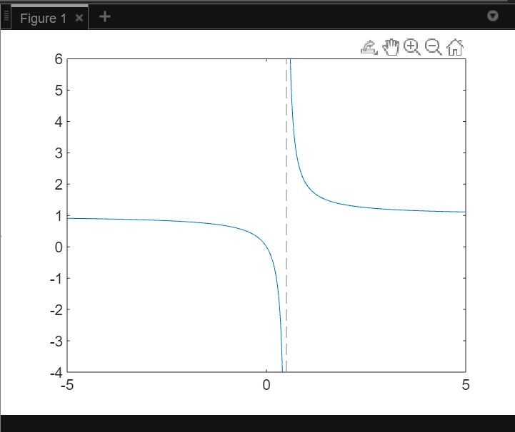

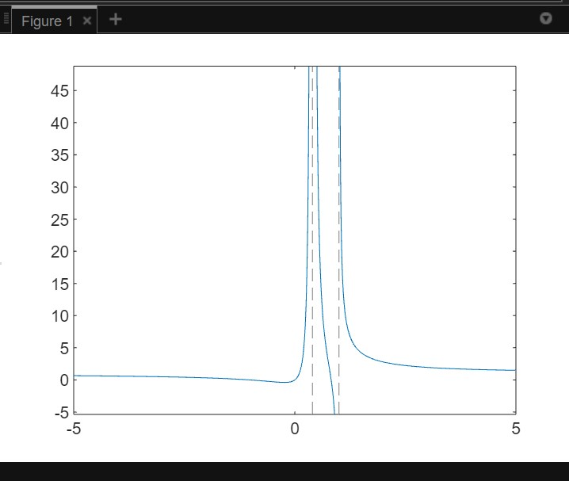

3) Write a MATLAB/ Python program to find inverse z-transform of the following z-domain signals.

a) 1/ (1 - 1.5z-1 + 0.5-2)

b) 1/((1 + z-1 ) + (1 – z-1 )2)

**ANSWERS**

**CODE**

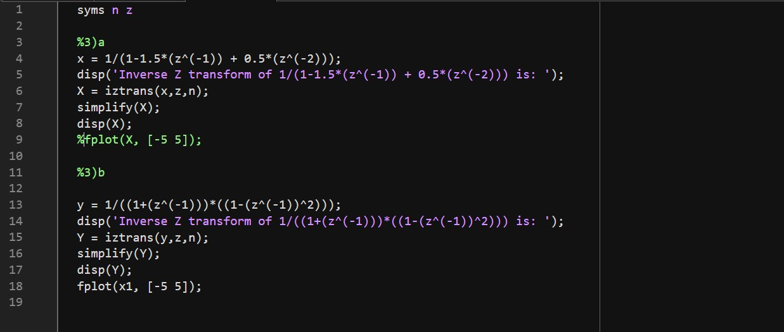

**OUTPUT**

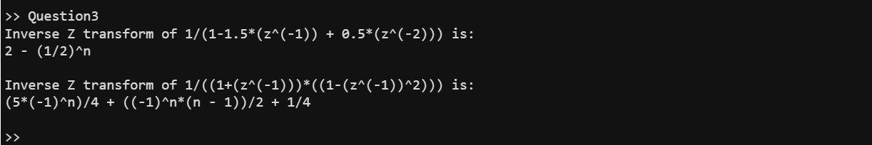

**GRAPHS (one for each subpart, in order)**

